'How to' Fit a Classic

Mini Moulded Carpet Set

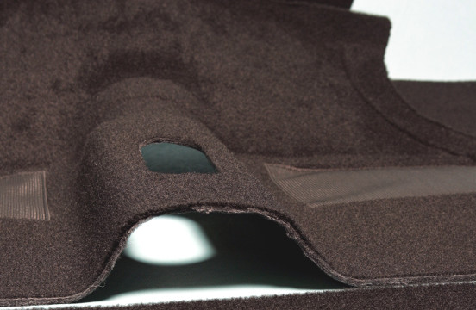

Written by: Owen Phillips
Published: 8 November 2013
Courtesy of: Newton Commercial
A step by step guide- how to fit a Classic Mini Moulded Carpet set into your Classic Mini.
Fitting your moulded Classic Mini carpet set
Our moulded carpet sets are one of our top selling products. They are fairly simple to fit because, being moulded, the mats hold their shape and quite clearly follow the floor-pan. The front and rear mats therefore will fit with only minimal trimming and with a few holes needing to be made, such as for the steering column or gear lever. The rest of the carpet set needs to be thoroughly glued and positioned in place as desired. Many original Minis were never fitted with a great deal of carpet beyond a pair of mats covering the front and rear floor pans, but our set includes pattern shaped pieces to completely cover the front wheel-arches, sills and cross-member. Fitting the whole kit if done thoroughly and properly, should be planned as a leisurely and satisfying days work for one person. You will get through at least two cans of glue, so the job is best done in a well ventilated area or even outside on a good warm day. You will need a heat gun or hair dryer, a pair of sharp scissors, a bradawl (spike), a small hammer, a circle punch of about 1 ½” diameter, some chalk for marking out, and a selection of screw drivers for replacing any fittings specific to your car such as the gaiter retainer. A small ink roller may also prove to be of advantage for pressing the glued pieces firmly into the car, and a good foam cushion/kneeling pad with a clean and hard wearing cover will save your knees!

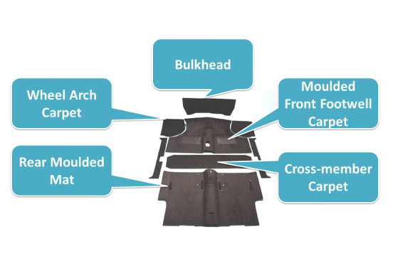
Step 1 – Preparation and sound deadening under-felt
Our sample car had a very nice floor pan which had been welded and then stone chipped in black, so it was all really well prepped, clean and shiny. Good practice for the long term future of the car, and it made quite an unpleasantly cramped working environment that much easier to bear. We recommend that anybody investing time and money in a new carpet set, first surveys and considers any work that should be done to the notoriously patchy Mini floor!
Sound deadening felt should be used to cover the bulkhead and fill the drain wells in the front floor pan. This smoothes out the floor and also reduces the drumming present in the car, particularly on the bulkhead just inches away from the noisy little A-series motor. Some trimming will be needed to cut the pieces to shape depending on equipment fitted to the car (ICE cables etc.), but generally all can be applied with an appropriate spray contact adhesive such as Evo-stick. A small roller used firmly, or a light tap with a blunt hammer all over the felt pieces does help the glue do its job once in position. We made good use of our self adhesive bitumen pads (PT 4008), very easily positioned with the aid of a heat gun to soften them up first. These are ideal for insulating the front and rear floor pans against drumming.
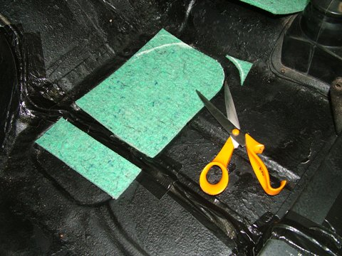
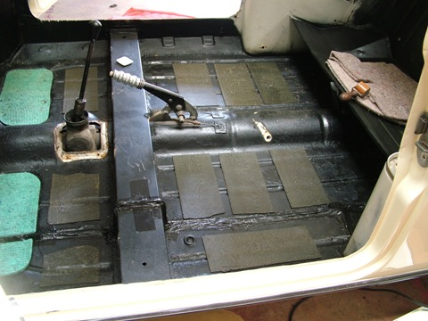
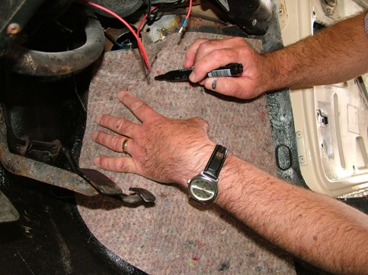
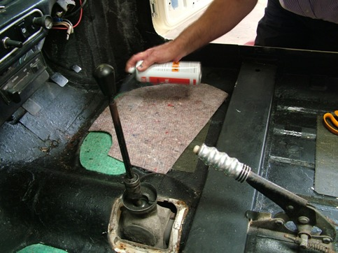
Step 2 – Fitting the flat carpet pieces into the car
As mentioned above, wheel-arch, sill, bulkhead and cross-member covering carpet pieces are included in all of our kits. These all need to be trimmed to fit and glued into place, so again all you should need is a pair of sharp scissors and a quantity of spray adhesive for the majority of the work there. The trickiest piece to fit is probably the bulkhead (again depending upon how cluttered your Mini is under the dash area- no two are the same!), although the cut outs in the felt piece are a good guide to the trimming needed for this. The wheel-arch carpets need to be arranged correctly, so be sure you have got them lined up to the right edges as it isn’t always so obvious straight from the bag. We suggest a dry-fit is trialled first, before spraying along the inside back edge of the A-panel and the straight back edge of the wheel-arch carpet, and lining up so that about an inch flange can be glued flat to the floor all around the bottom to sit under the main floor mats once these are dropped in.
The cross-member needs to be located and then weighted on one side before gluing up the other- don’t attempt to glue the piece in one go as this will be very tricky to get right. The ends of the cross-member piece will need to be trimmed and slit before then gluing any flaps down onto the body. The seat bracket holes can be difficult to find- this is where a bradawl or similar spike comes in really handy. With some trial and error the threads for the bolts can be found, and then your scissors can be used to snip the openings slightly bigger. The sill pieces should be fitted last off, again trial fitting, trimming and then gluing. At all times be aware that you are working in a confined space, and be very careful not to get glue onto the face of the carpet- we used a sheet of old brown paper to mask any areas where we were spraying up.
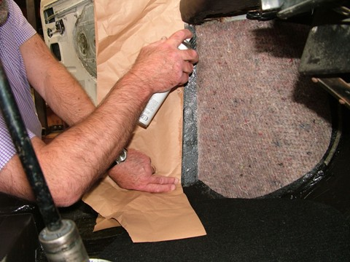
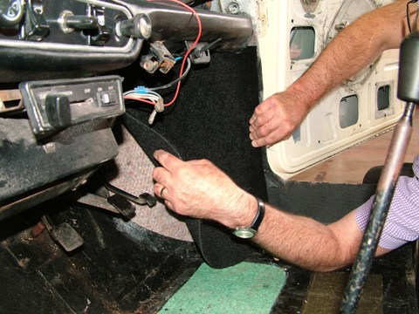
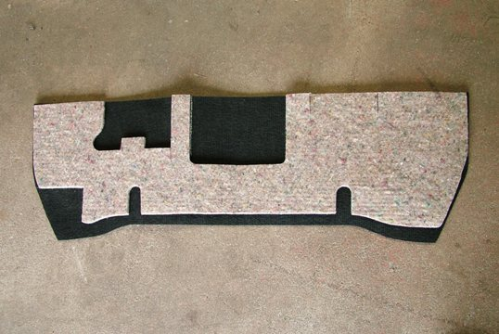
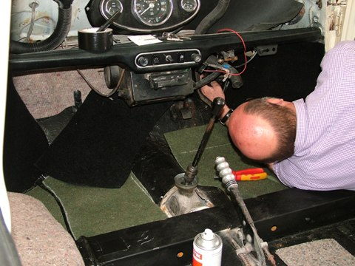
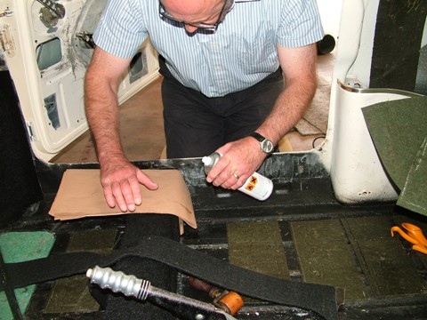
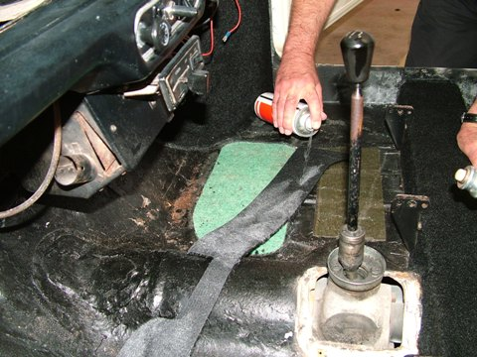
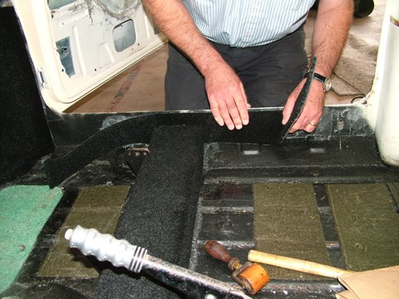
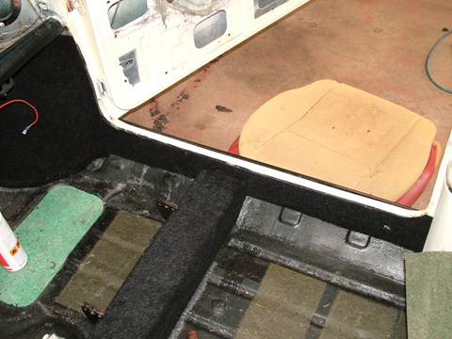
Step 3 – Finishing and fitting the main mats
Both the front and rear mat are supplied trimmed to the correct shape and with heel-mats and seat bearing plates already fixed on. The most difficult part of fitting these then is the making of holes in the right place for the gearlever and/or gaiter (depending on model) and for the floor mounted seat belt gear which can differ but will be present on the vast majority of cars. If you have the original carpets, these are ideal for making a comparison of holes and openings, but otherwise the carpets are best marked out for fitting by careful measurement and a certain amount of careful trial. Remember to make small holes first, to be confident that your location is correct- small holes can always be steadily opened up. An opening for the steering column is quite easily made with the column taken out; once the front mat fits in around the gaiter and is very nearly sitting in its finished position, feel for the base of the column and mark with chalk on the carpet. The front corner of the mat can then be folded back, and by firmly twisting the punch into the foam carpet backing onto a piece of spare timber, the correct hole can be made. The front mats should then drop into place easily with no visible gaps all round.
The gear lever gaiter (where fitted) can be a fiddly thing to fit back on- make sure the rubber seal is sandwiched between the carpet and the body, not vice-versa. This will make for a more weather proof seal on top of the gear selectors and stop your new carpet from getting damp. The bradawl or spike will then come into play again as the holes for the self tapping screws will need to be found, although these are to a degree given by the necessary holes in the retaining steel ring.
The same punch can be used to create the right apertures for the seat belt bracket mounting to fit the rear mats- these have to be made by removing all of the belt gear from the handbrake tunnel, and then by placing the carpet into the rear of the car fitting it up tightly to the rear bulkhead and around the rear pockets. When you are happy with the fit of the rear carpet mat, use the bradawl to work a largish hole in the carpet or mark with chalk directly in the threads for the seat belt bolts, before resorting again to the punch to make the final hole. The seat belt bolts are normally quite large and the thread sometimes difficult to find through the thick carpet, so make sure you help yourself by making them big enough to pass the bolt through!
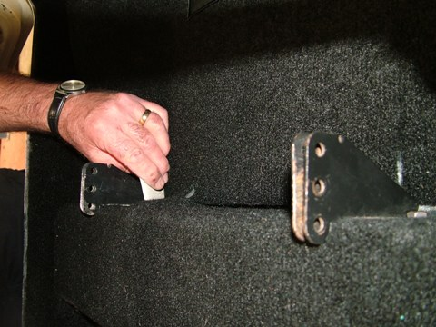
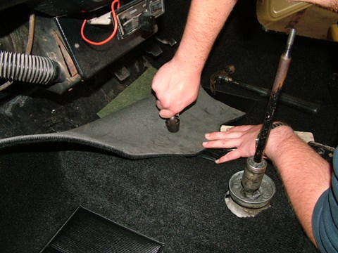
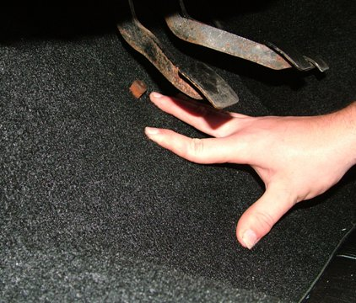
Step 4 – Stand back and admire your work
We are proud of our carpet sets; they look extremely smart when fitted correctly. Take a break with each stage and you will quite clearly see good progress which is a big help when you are working in small and uncomfortable cars! We are chuffed with the finished product every time we fit a carpet for a customer. So there you have it- none of the individual jobs can be considered rocket science but, patience in approach and attention to detail will pay dividends.
